**Problem Statement:** This assignment is designed to help you understand how to plan and develop the front end for a given problem, gain hands-on experience in designing the database for the project, and sync the code with a distributed version control system like GitHub.

1. Create a project in Jira or any other project management software

Created project in Github

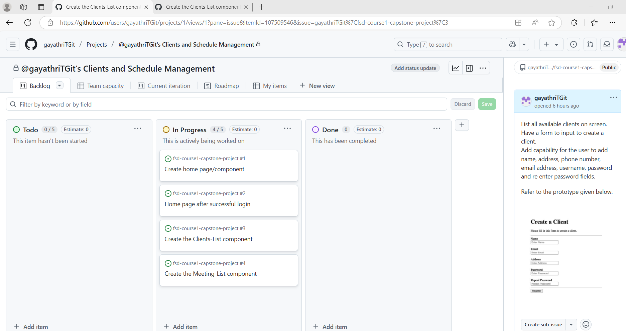

1. Create epics for clients and client meetings and Create user stories in the epics

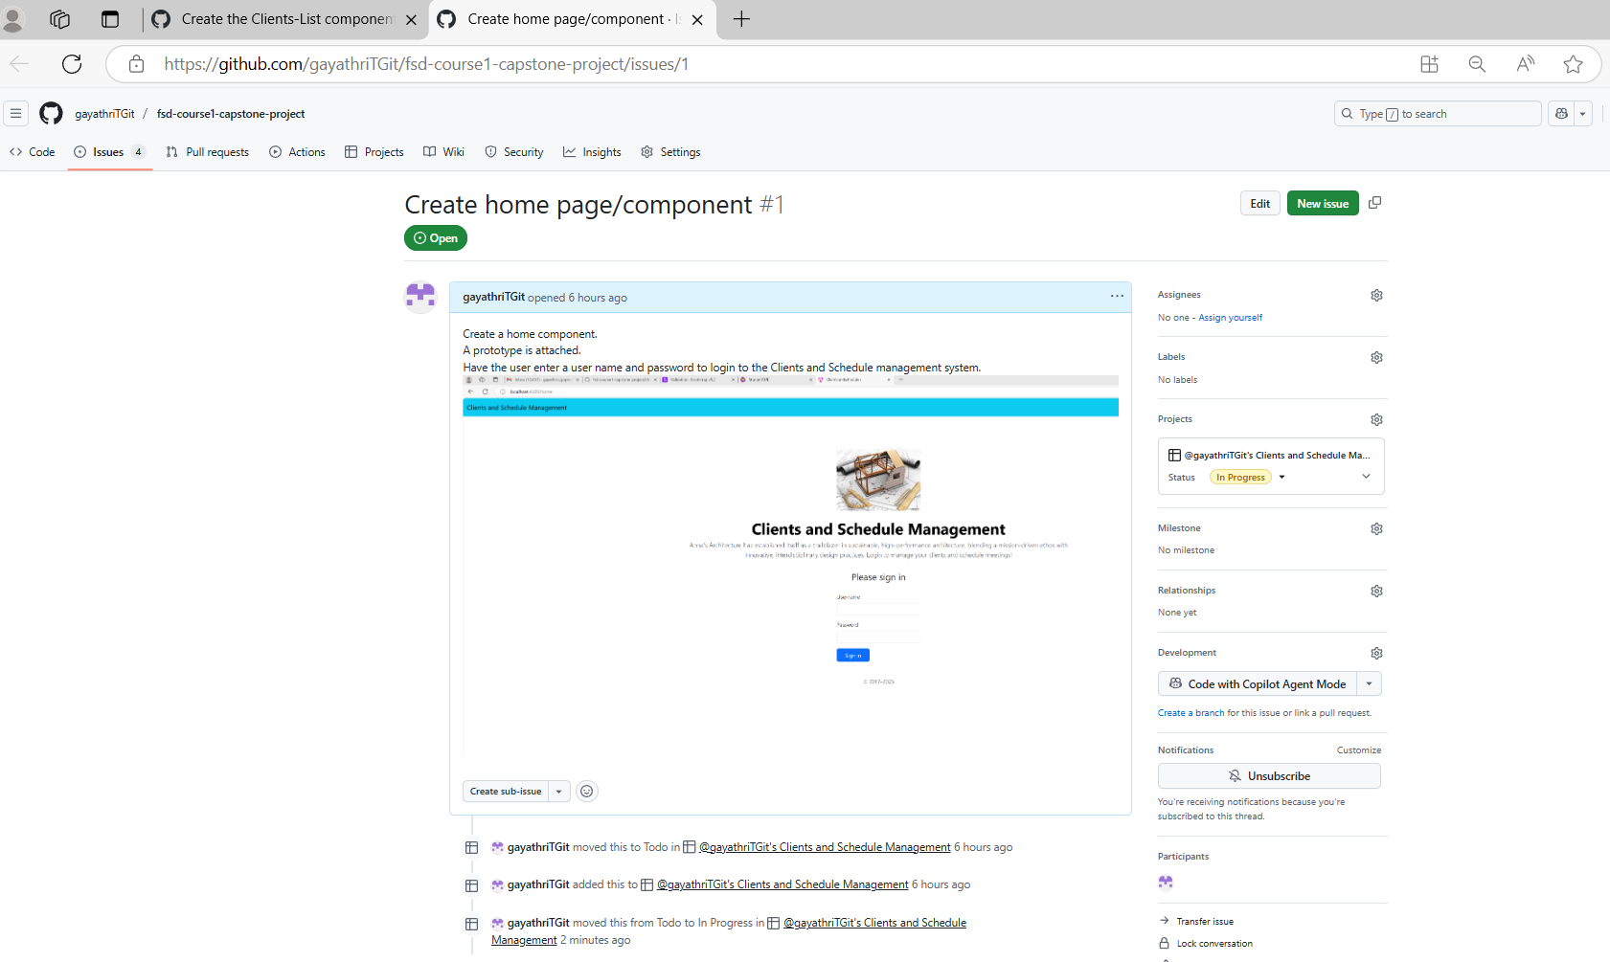

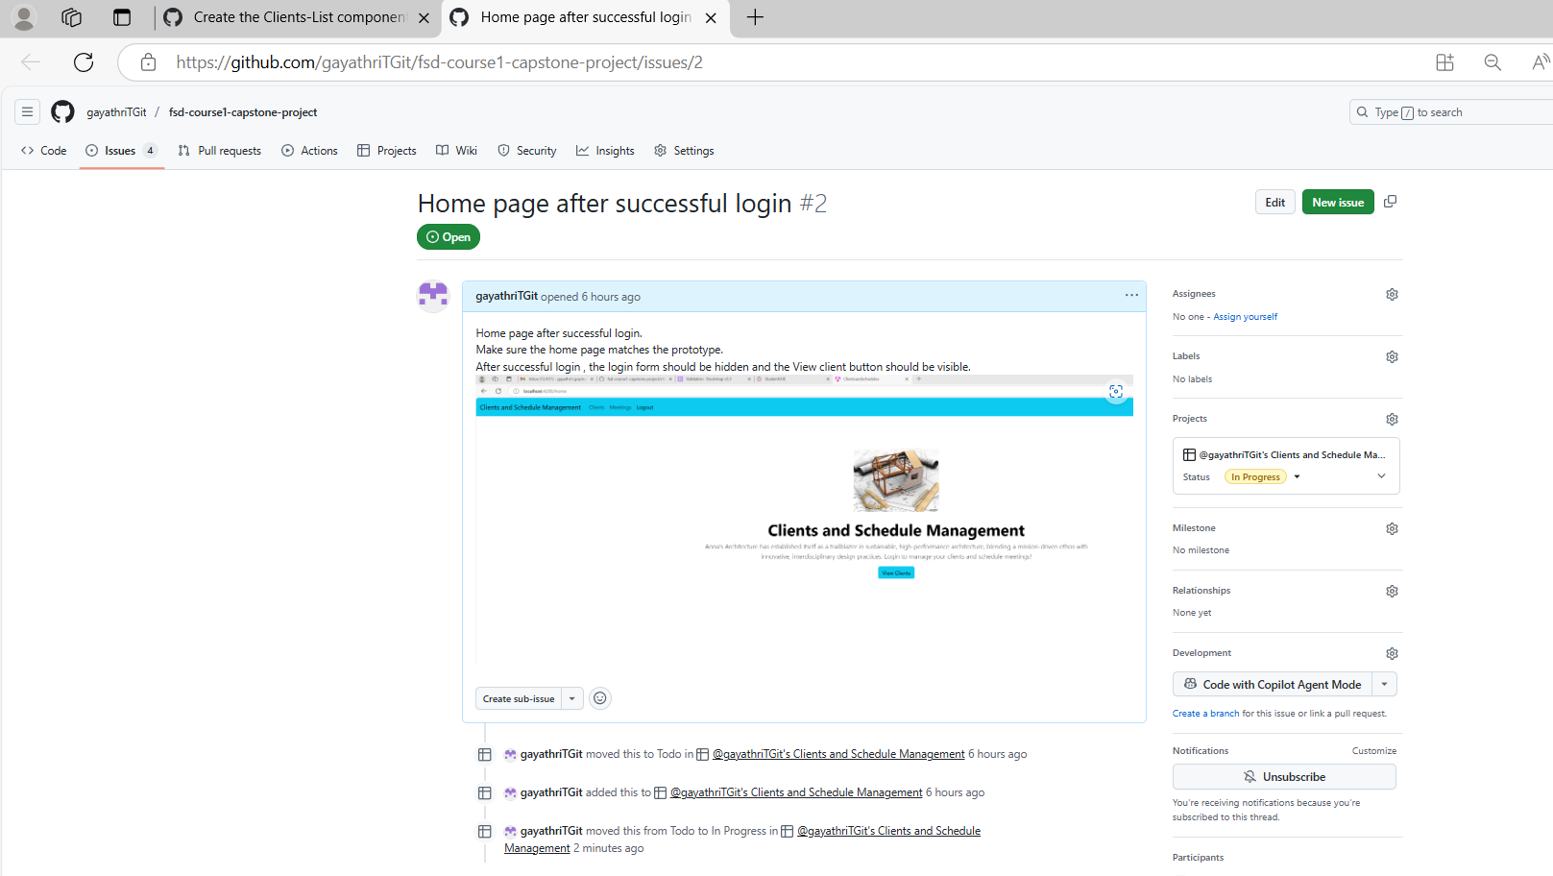

## 

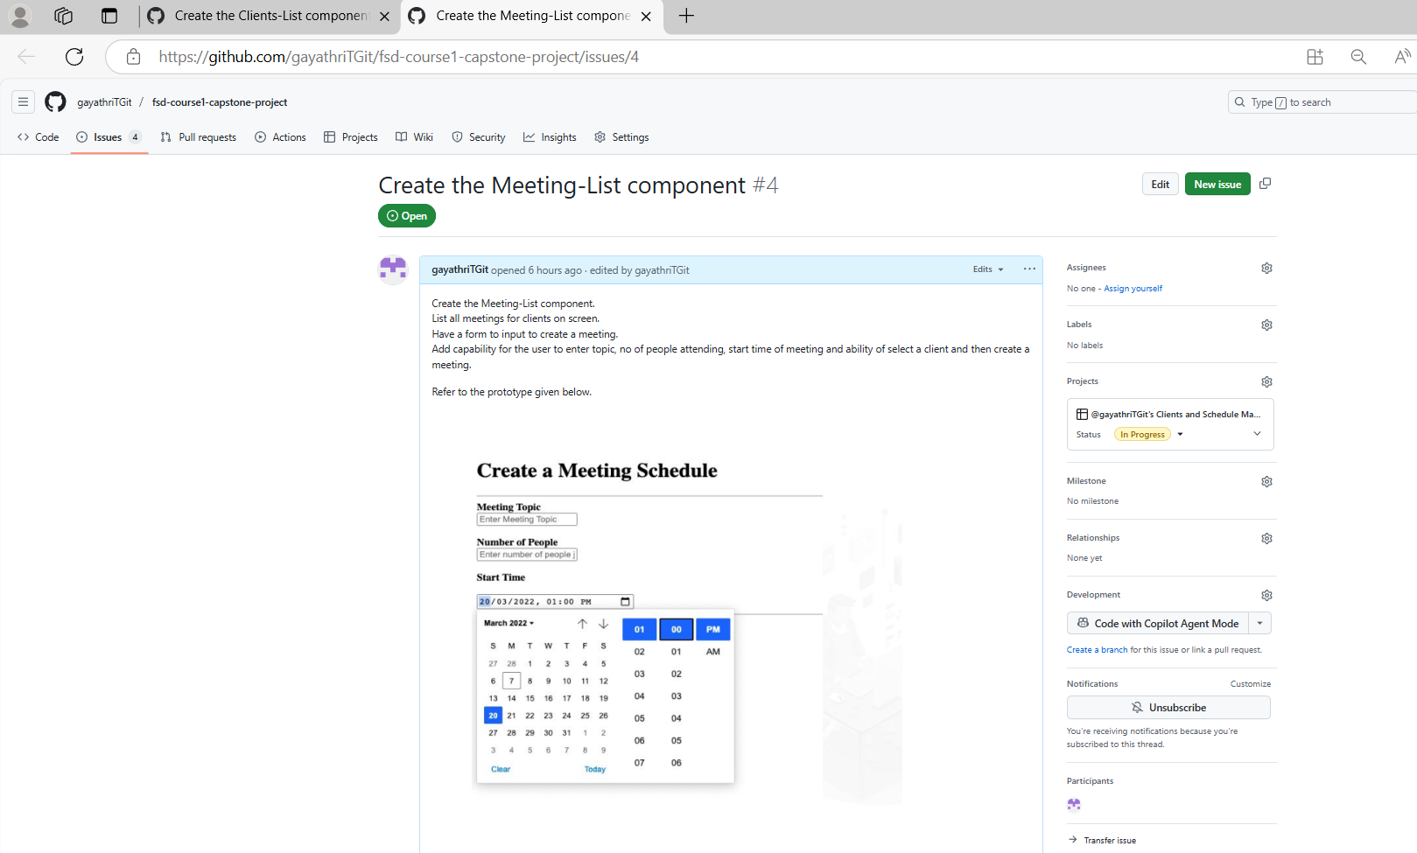

Design the web pages for client creation and client meetings using HTML and CSS

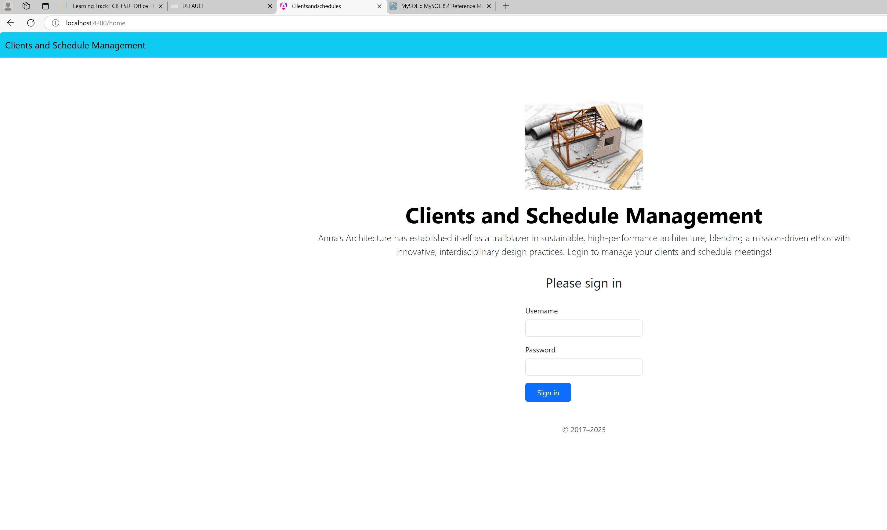

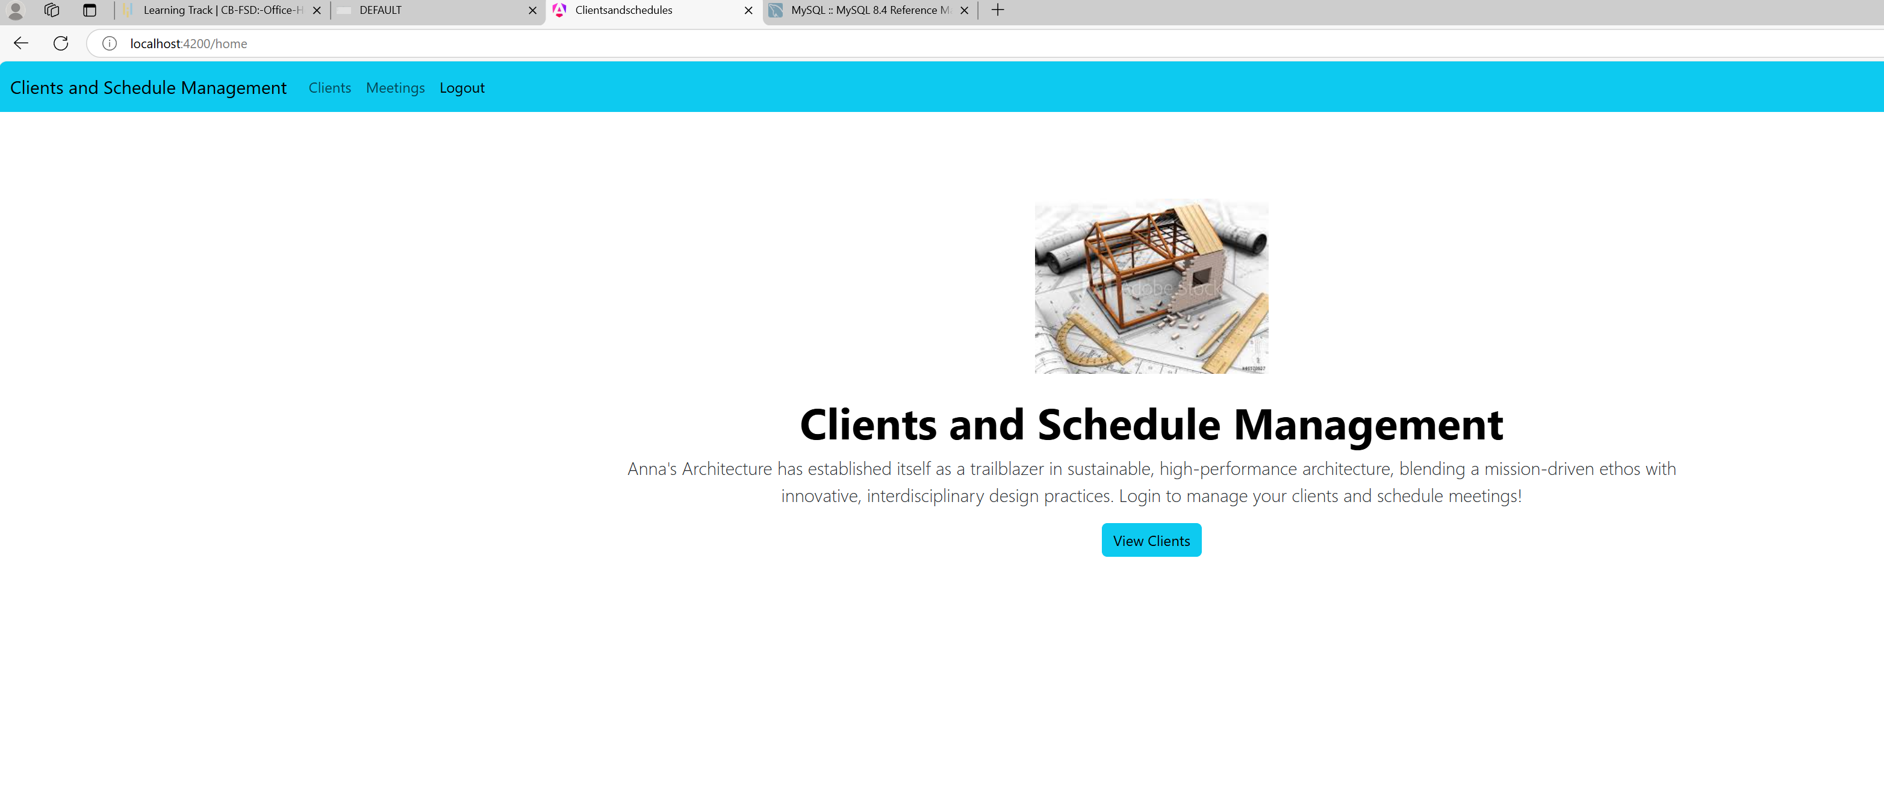

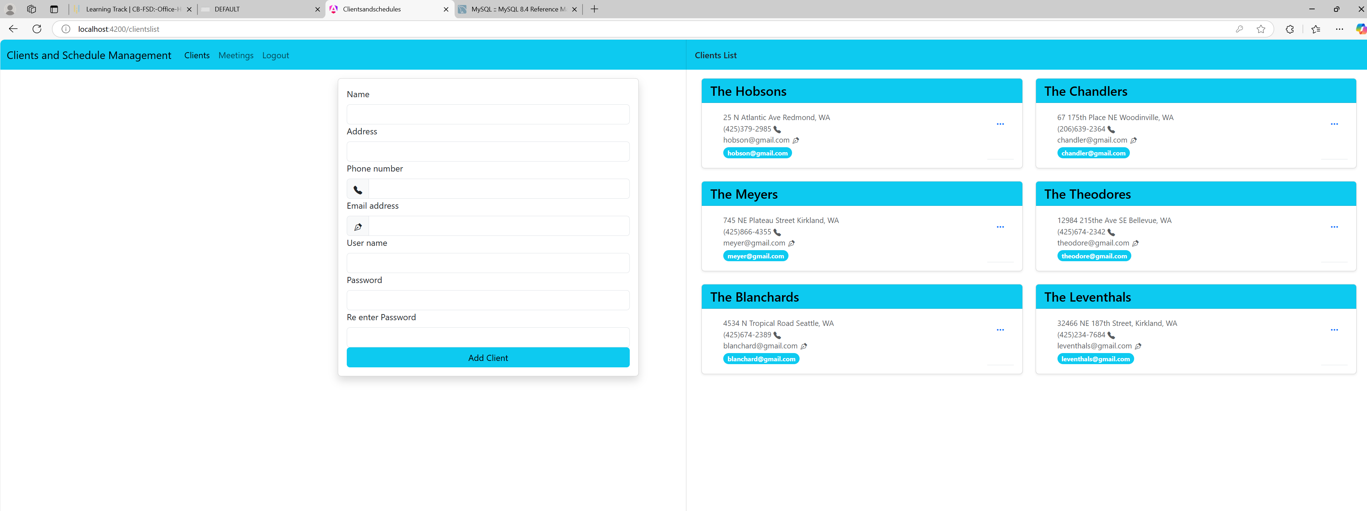

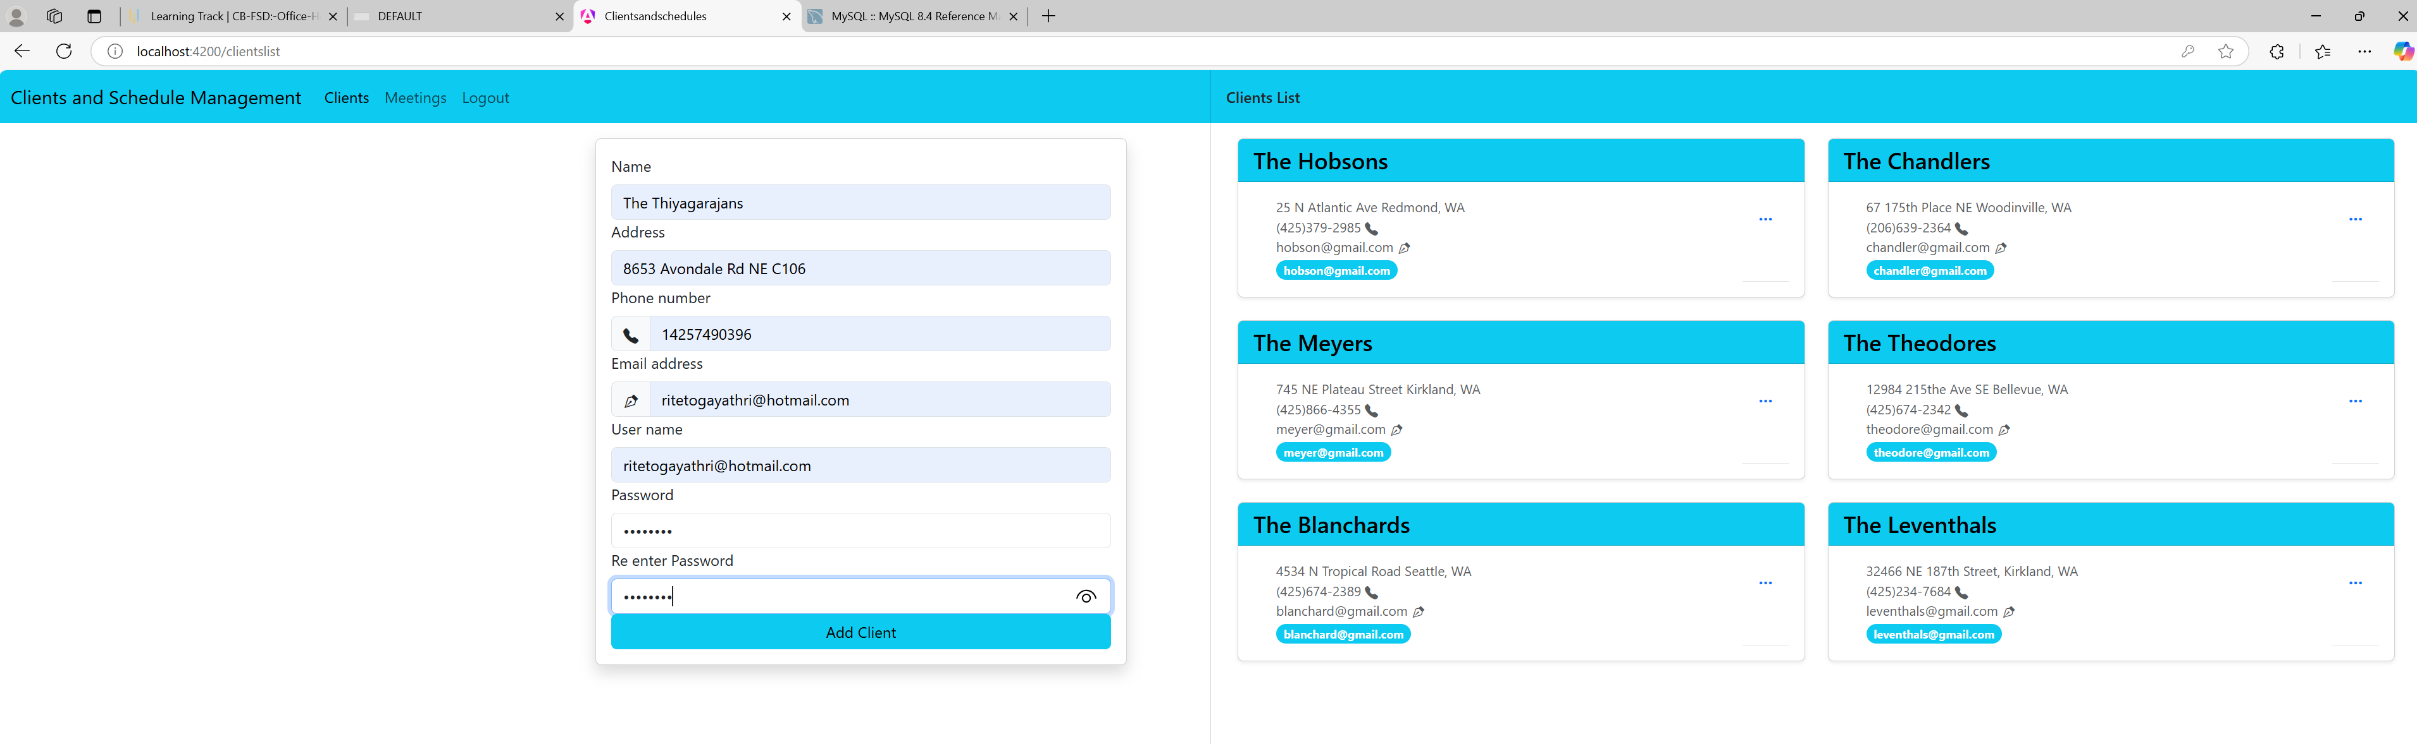

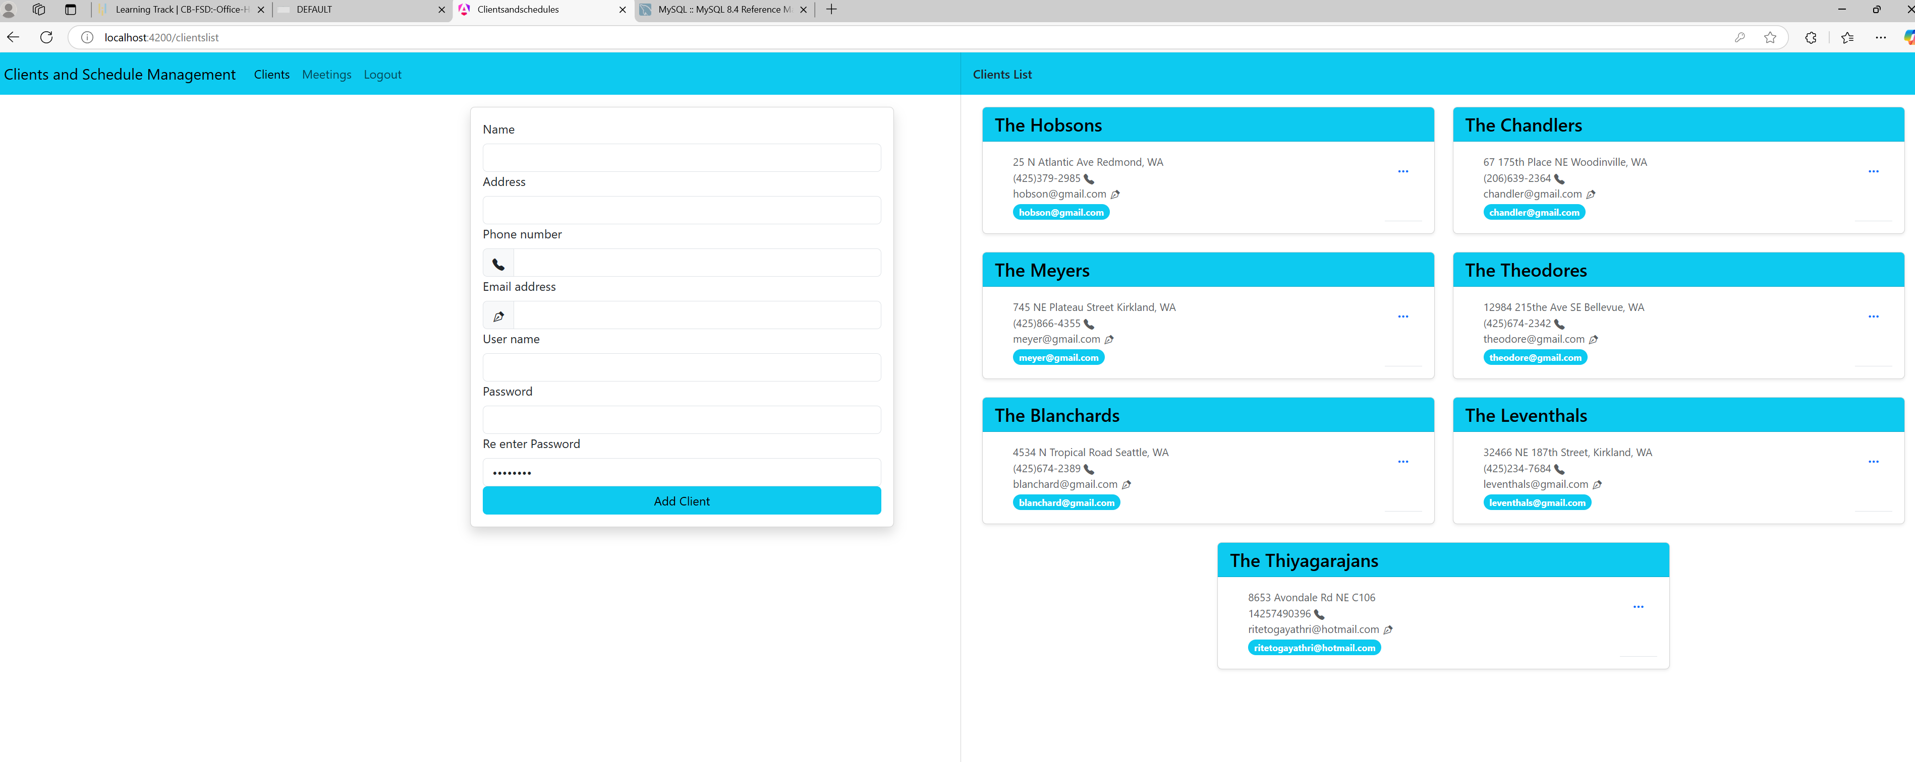

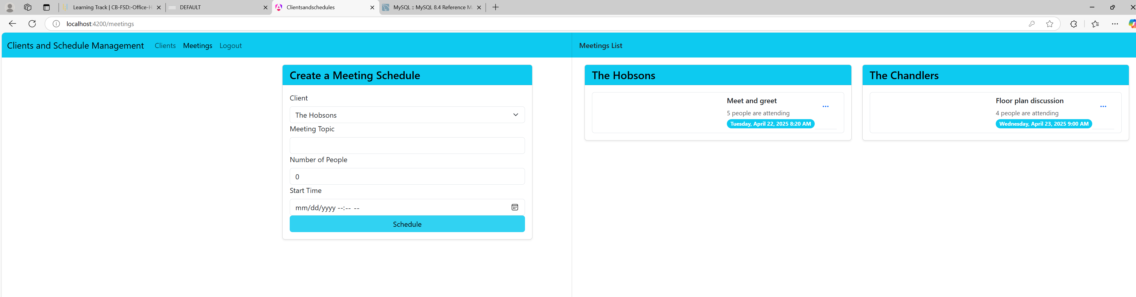

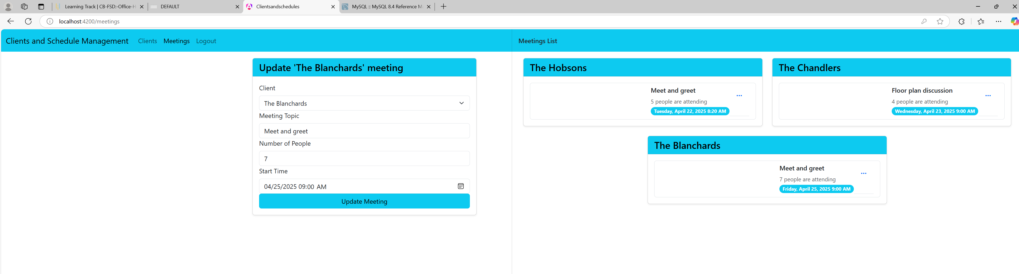

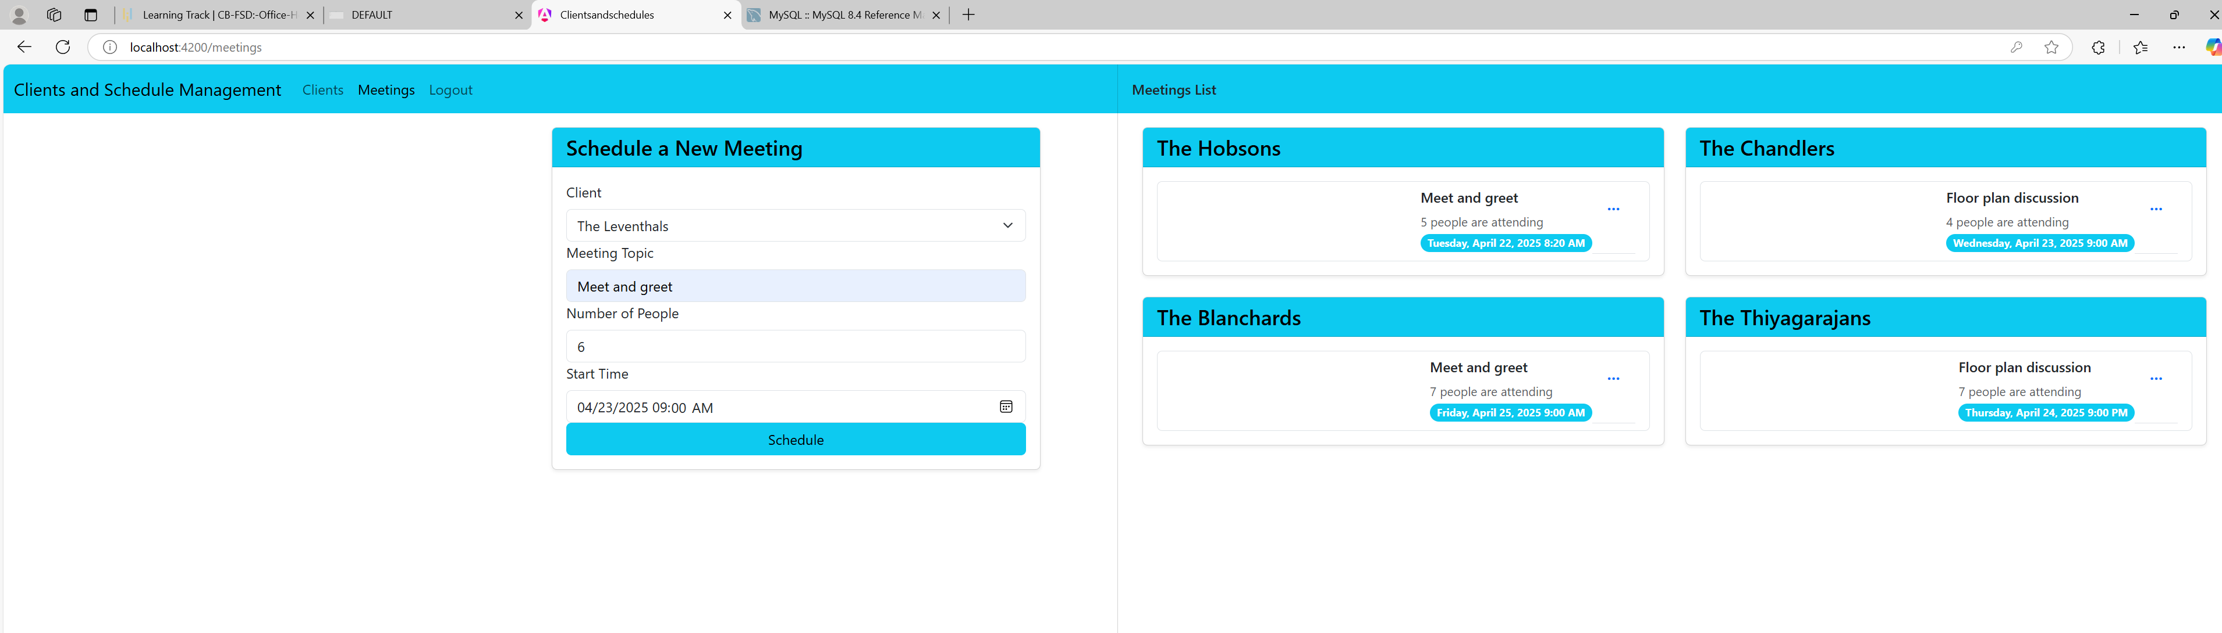

Develop a web application and create various required components for client management using Angular

Source code checked into the following Github repository

[gayathriTGit/fsd-course1-capstone-project](https://github.com/gayathriTGit/fsd-course1-capstone-project)

Design the necessary tables for clients and meetings in MySQL

create table Clients (

id INTEGER PRIMARY KEY AUTOINCREMENT,

name TEXT not null,

address TEXT not null,

phonenumber TEXT not null,

emailaddress TEXT not null,

username TEXT not null,

password TEXT not null

);

create table Meetings (

id INTEGER PRIMARY KEY AUTOINCREMENT,

clientid INTEGER not null,

clientname TEXT not null,

topic TEXT not null,

noofpeopleattend INTEGER not null,

starttime DATETIME not null

);

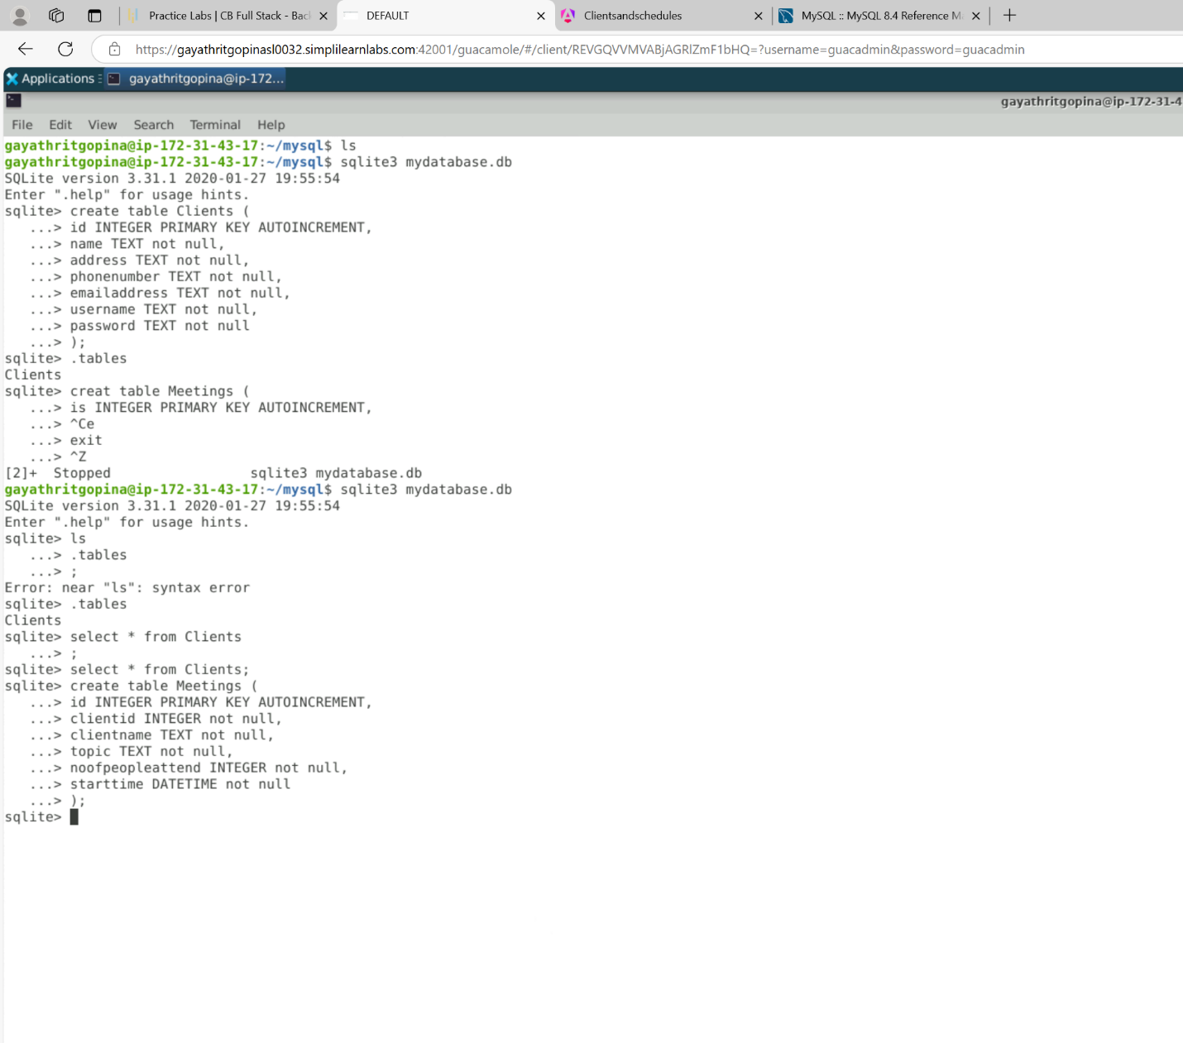

Run your Angular Project

















Sync your code to GitHub

[gayathriTGit/fsd-course1-capstone-project](https://github.com/gayathriTGit/fsd-course1-capstone-project)